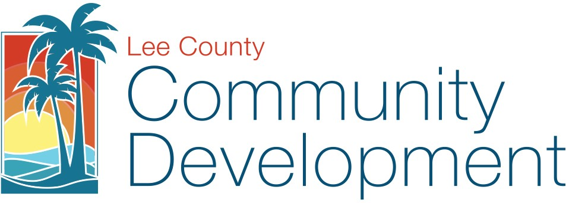
REQUEST FOR WAIVER OF STATUTORY ZONING APPLICATION REVIEW DEADLINES

Please email application to ZoningAdmin@leegov.com or submit to the Zoning counter at 1500 Monroe St. Fort Myers, FL 33901. Call 239-533-8585 with questions.

*Please provide the required information below.

*Project Case Number:
*Project Name:
*Applicant Name:
*Phone Number:
*Email:

Applicant hereby requests a waiver of the statutory development order review deadlines found in § 125.022, Florida Statutes, for the application identified above. This waiver will allow additional time for Applicant to submit, and for Lee County to review, any supplemental or corrected materials which have been deemed necessary by the Department of Community Development to substantiate compliance with the applicable application requirements of the Lee County Land Development Code. Applicant acknowledges that the maximum response time, notwithstanding this waiver request, is 365 days from the original submittal date at which time the submittal must be approved, approved with stipulations, or denied.

*Signature |  | *Date

Web/WaiverStatutoryDeadlines_Zoning (10/2025)

